**Team Project:**

**Deliverable 1 - Proposal**

**CSCE 5430 (Spring 2023)**

1. **Project Title:**

**Online Library Management System**

**Group Name:**

**Penguins**

**Group Members:**

| **No.** | **Name** | **Student ID** | **Email** |
| --- | --- | --- | --- |
| 1 | Ashraf Syed | 11618668 | [AshrafSyed@my.unt.edu](mailto:AshrafSyed@my.unt.edu) |
| 2 | Padmini Kuchukulla | 11605145 | [KuchukullaPadminiLNU@my.unt.edu](mailto:KuchukullaPadminiLNU@my.unt.edu) |
| 3 | Abhijith Reddy Mandagiri | 11603247 | [AbhijithReddyMandagiri@my.unt.edu](mailto:abhijithreddymandagiri@my.unt.edu) |
| 4 | Deepna Thalanki | 11644830 | [deepnathalanki@my.unt.edu](mailto:deepnathalanki@my.unt.edu) |
| 5 | Raghu Vamsi Kondapalli | 11663360 | [raghuvamsikondapalli@my.unt.edu](mailto:raghuvamsikondapalli@my.unt.edu) |
| 6 | Vamsi Venkat Manepalli | 11656561 | [Vamsivenkatmanepalli@my.unt.edu](mailto:Vamsivenkatmanepalli@my.unt.edu) |
| 7 | Sai Vishwak Jadala | 11673439 | [saivishwakjadala@my.unt.edu](mailto:saivishwakjadala@my.unt.edu) |

1. **Project Description :**

**Motivation :**

The library is crucial to teachers' and students' everyday instruction, academic inquiry, and learning. The use of computers to manage library book information could considerably increase management efficiency while reducing manual management errors. It might guarantee the accuracy of the data in the book and hasten the turnover of its resources. Therefore, utilising computers to manage information from library books had a huge impact. The database contained all of the integrated data used by a company, organisation, or department. The database's use and maintenance comprised the basis of the library management information system. Our suggested system will be available 24/7 for book searches and reservations, and it will be built for computerising all library activities.

**Major Functions/Idea :**

We are developing a library management system with voice-based book searching and automatic genre classification based on book titles. Based on the book's title, authors, and information gathered online, the system will conduct an internet search to gather information on the book and group it into the proper categories.

Features of Admin User

* Register New Book:
  + This feature allows the admin to add new books to the library where the system verifies the information to enter book details, number of copies into a database table and does not allow two books having the same book id.
* Automatic Categorization:
  + This feature is done by system internally, when admin adds a book into the system it categorises the book based on genre.
* Issue and Return Books:
  + This feature allows the admin to issue,return books and also view reports of book issues which also helps to enter issue information in the database, update number of books, search if a book is available or not before issuing books, to enter issue and return date information, where return date is set to 15 days.
* View Registered Students:
  + This feature allows the admin to view reports of students registered into the system.
* Fine Calculation:
  + This feature calculates the fine, if any. System searches the database for issue and return dates and calculates the fine for present date accurately

Features of Student User

* View Books Issued to the user :
  + This feature allows students to view the books issued to them where the system searches the database for books borrowed based on requested students and shows the filtered student’s borrowed books.

**Objectives :**

The main objectives of our project are:

* Distinct product users based on their roles and permissions
  + Admin
  + student
* Authentication of users at their login
* Provide interface to add or issue books and view registered students for staff
* Status page for students to view the books borrowed by them
* Facility to search books based on voice
* Automatic genre classification based on a book's title.

**Development environments :**

* For Front end
  + HTML, CSS
    - For developing client-side web pages.
  + Bootstrap
    - To develop interface components like buttons, navigations,etc.
* For Back end
  + Django
    - It is an object relational mapper which generates a back end interface for web management in a secure way.
  + Python Libraries
    - Django: It is a sophisticated Python Web application framework that emphasises explosive growth and clear, functional design.
    - Psycopg2: Python-PostgreSQL database adapter
    - Requests: It is an appealing yet basic HTTP library.
    - Beautiful Soup: It's a library that makes it simple to get data from websites. It provides Pythonic idioms for iterating, searching, and altering the parse tree and sits on top of an HTML or XML parser.
* For Database
  + PostgreSQL
    - A robust object-relational database with many current capabilities, including complicated queries, foreign keys, transactional integrity, multiversion concurrency management, etc., PostgreSQL is open source and supports a significant portion of the SQL standard.
* Environments:
  + PyCharm IDE - for python
  + pgAdmin - for database

**6. Initial Planning :**

As part of the initial planning, we have set up weekly gatherings every Tuesday to discuss all the project updates and help each other if there are any challenges. For the first two weeks, we got introduced to each other and got to know each other’s strengths, weaknesses and their area of technical interests. For the second and third weeks, we had discussed various ideas on which we should work for this semester group project. Then, finalised our ideas and segregated the project’s plan among the group accordingly. By week 4 i.e, 01/31, we will be able to gather the requirements. We will be familiarised with the upcoming risks and how to deal with them while working on the project by the end of week 5 i.e, 02/06. From week 5 to week 8, we will work on what are the requirements and specifications / features of the software / hardware for our project and during this time, we will also divide our project into 3 phases. We are planning to complete the implementation of phase 1 by week 11 i.e, 03/20. We would complete the implementation of phase 2 by week 15 i.e, 04/10. The final phase implementation would be completed by week 17 i.e, 05/01. Then, we are planning to work on testing of our software, which we are planning to complete by week 17. We are planning to complete the whole testing part of our project and the final version of our project will be submitted by the 17th week i.e, 05/01.

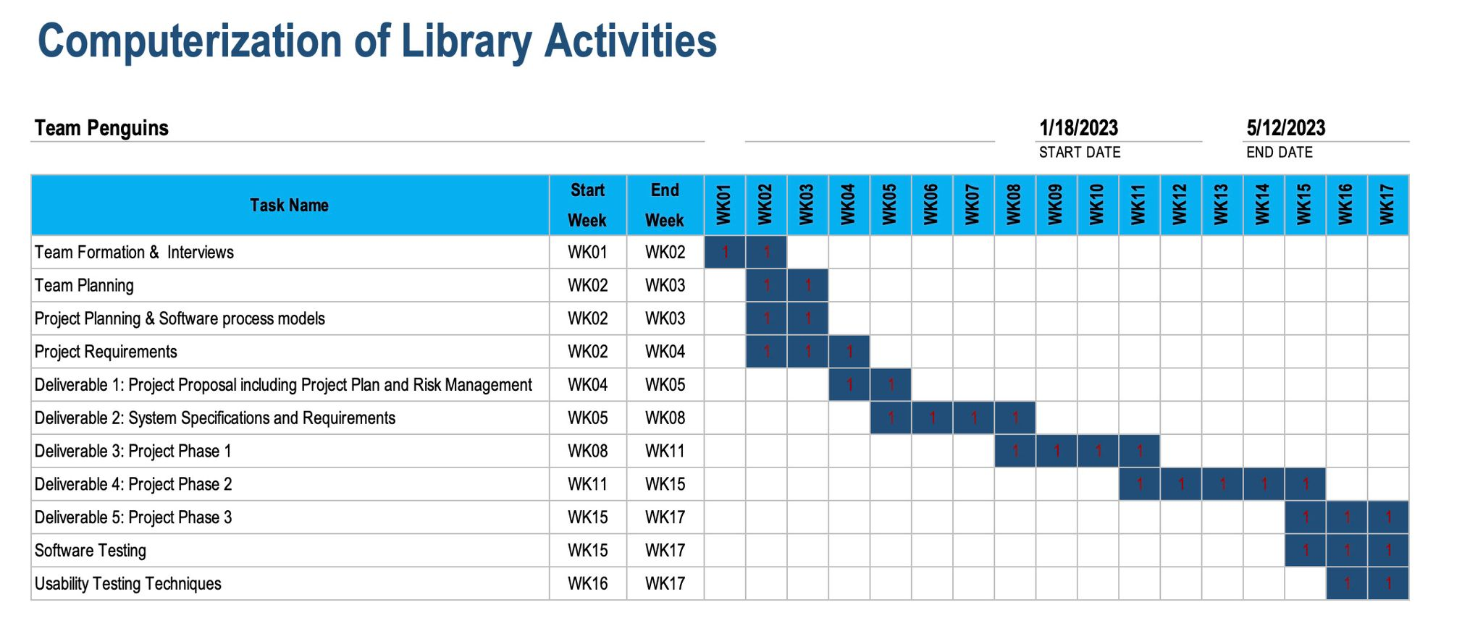

**Gantt Chart**

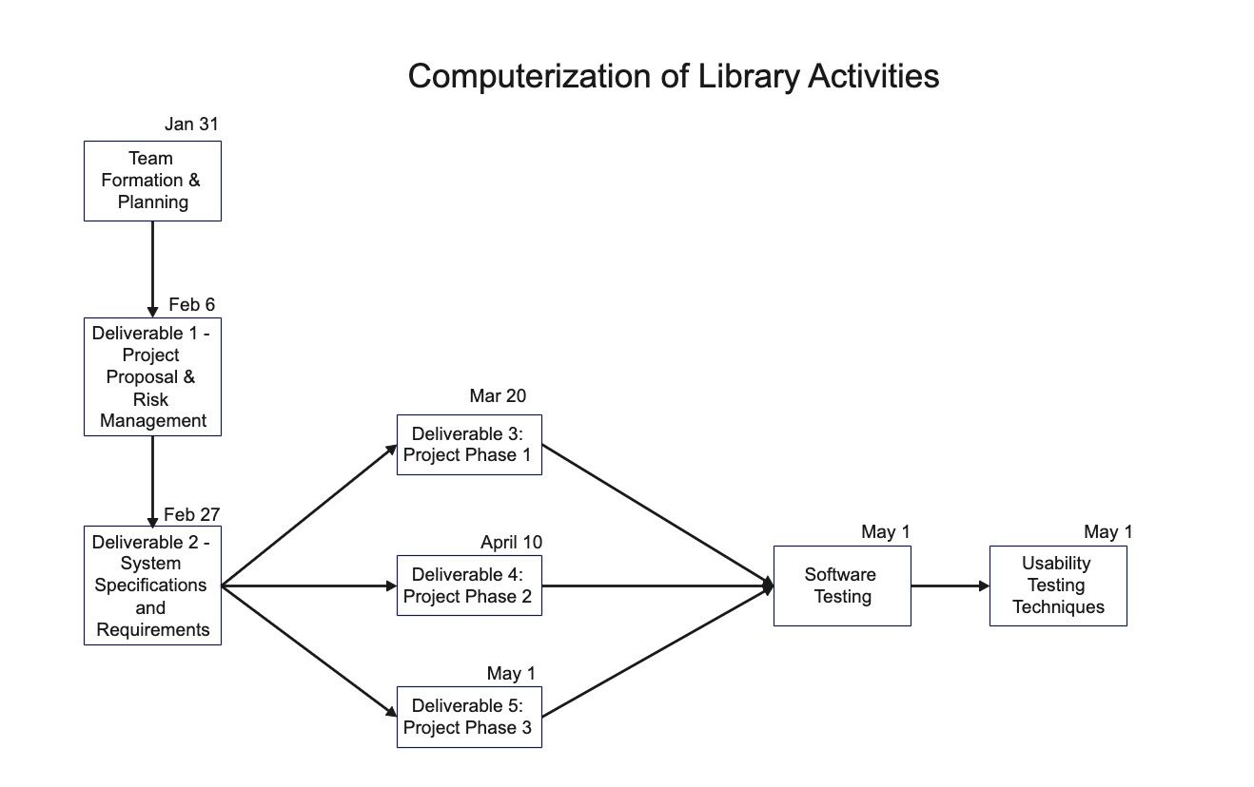

**PERT Chart**

**7. Risk Management :**

* **DATA REDUNDANCY WITH IN APPROPRIATE SEARCH:**

Duplicate data might cause data inconsistencies.

* **DETAILED SEARCH FOR REQUIRED RESULTS :**

When there is more than one book available with the same name or same Author .

* **VOICE SEARCH NOT RECOGNIZING** :

As when you use voice search there is a chance of auto correction of words , which in turn may change the name of the book.

* **FILE NOT SUPPORTED BECAUSE OF EXTERNAL SOURCE :**

Either file is not supported or else the file is corrupted.

**8. Team Member’s Role:**

| **Member name** | **Role** | **Note (if applicable)** |
| --- | --- | --- |
| Ashraf Syed | Backend / Frontend |  |
| Padmini Kuchukulla | Frontend / Database |  |
| Abhijith Reddy Mandagiri | Backend / Database |  |
| Deepna Thalanki | Frontend / Backend |  |
| Raghu Vamsi Kondapalli | Backend |  |
| Vamsi Venkat Manepalli | Frontend |  |
| Sai Vishwak Jadala | Database |  |

**Member’s Contribution:**

| **Member name** | **Contribution description** | **Overall Contribution (%)** | **Note (if applicable)** |
| --- | --- | --- | --- |
| Ashraf Syed | Powerpoint | 33% | Initial Plan, Risks |
| Padmini Kuchukulla | Report | 25% | Project Description |
| Abhijith Reddy Mandagiri | Report | 25% | Initial Planning |
| Deepna Thalanki | Report | 25% | Gantt Chart / PERT Chart, Created Folder Structure |
| Raghu Vamsi Kondapalli | Powerpoint | 33% | Abstract, Introduction, Problem Statement |
| Vamsi Venkat Manepalli | Powerpoint | 33% | Objectives, Scope, Technology Review |
| Sai Vishwak Jadala | Report | 25% | Risk Management |